Users may initiate remote access requests via the [Remote Access Portal (RAP)](https://vaww.ramp.vansoc.va.gov/) (available via the internal VA network only). In the event a user does not have access to the VA network, their supervisor/COR may initiate a request on their behalf.

1. Connect to the [Remote Access Portal (RAP).](https://vaww.ramp.vansoc.va.gov/)
2. Click on the ***Self Service Portal tab.***
3. Existing users who wish to initiate a request for additional access, click the Request Access button and then skip to Step 10.
4. New users will immediately be placed into the registration of a ***New User Profile***. Account information will automatically be populated from Active Directory. You may optionally add a *Secondary Email* (RAP emails will be sent to both your VA email and secondary email) and *Secondary Phone*. Click ***Next***

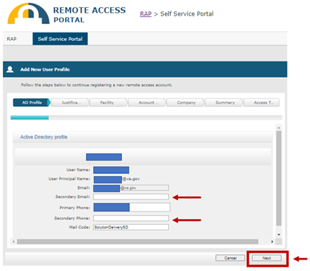

1. Enter a justification for your remote access request and click ***Next***.

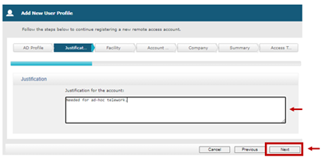

1. Select the state for your VA facility and then select the facility from the dropdown list. Click ***Next***.

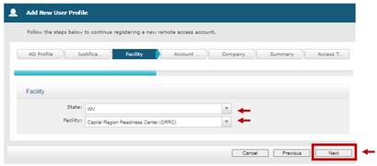

1. Identify the account type by selecting ***Contractor*** or ***VA Employee***. Click ***Next***.

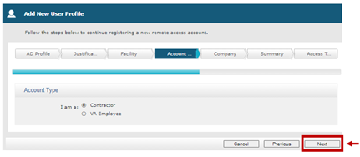

1. If *Contractor* was selected in Step 7, select your ***Company*** from the dropdown list. If VA Employee was selected, the ***Company*** will default to *Department of Veterans Affairs*.
   1. Select your ***Approving Official*** (supervisor or COR) from the dropdown list.
   2. If you do not see your ***Approving Official***, check the box to the right and follow the instructions on the popup form. Click ***Next***.

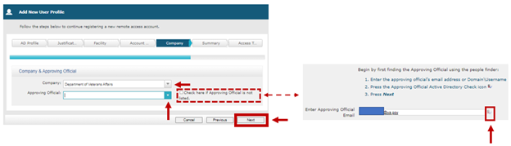

1. A ***Profile Summary*** page will be displayed. Review the information to ensure everything is correct. If anything is incorrect, use the ***Previous*** button(s) to navigate back and update your responses. Once the ***Profile Summary*** is correct, click ***Next***.

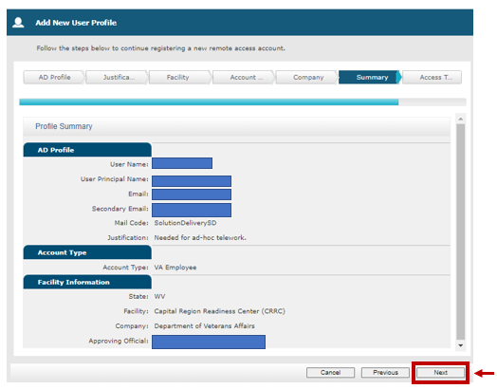

1. Select the device type(s) you will be using to remotely connect to the VA network. Click the blue *information* icons to learn information about each device type.

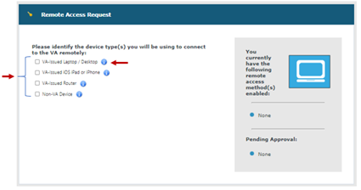

1. Depending on the device type(s) selected, recommended options will be displayed. Click the blue question mark icon to see a matrix of remote access methods mapped to device types; you may also click the additional *information* icons displayed by each connection method for more information on those options. Select at least one primary and one backup method and then click ***Submit***.

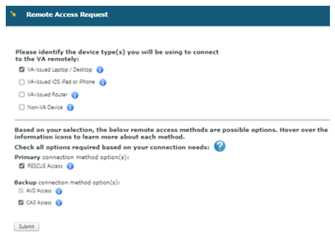

1. You will receive an email once your request is approved (or denied). The email will be sent to your VA email address and your secondary email address (if one was provided).
2. You may also see the status of your request within the RAP Self Service Portal by clicking the ***Access Request Details*** link under the ***Quick Menu***.