**September 17, 2024, AHD MKSAP Questions**

1. A 42-year-old woman is evaluated in the emergency department for 2-day history of headache, dizziness, and easy bruising. Her medical history is otherwise unremarkable, and she takes no medications.

On physical examination, temperature is 38.0 °C (100.4 °F), blood pressure is 150/98 mm Hg, pulse rate is 104/min, and respiration rate is 16/min. A neurologic examination is normal. She has no lymphadenopathy or organomegaly. Petechiae are noted on both legs.

**Laboratories:**

Haptoglobin: < 10

Hemoglobin: 8.2 g/dL

Leukocyte count: 10,200/ uL

Platelet count: 8,000/uL

Creatinine: 1.1 mg/dL

Reticulocyte count 8.5%

Peripheral smear:

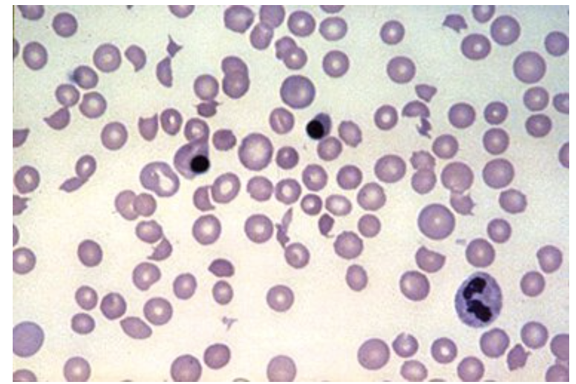

**Which of the following is the appropriate management?**

1. Plasma exchange
2. Intravenous nitroprusside
3. Platelet transfusion
4. Plasmapheresis with normal saline and 5% albumin
5. A 74-year-old man is evaluated in the hospital for new-onset thrombocytopenia. He was hospitalized 48 hours ago for management of CT angiography–confirmed pulmonary embolism. Medical history is significant for coronary artery bypass graft surgery 3 weeks ago. Medications are aspirin, clopidogrel, metoprolol, lisinopril, furosemide, and atorvastatin; low-molecular-weight heparin (LMWH) was initiated on admission to the hospital.

On physical examination, vital signs are normal. Other than a well-healing sternotomy scar, the physical examination is unremarkable.

**Laboratories:**

Hemoglobin: 12 g/dL

Leukocyte count: 11,500/uL

Platelet count: 90,000/uL (at admission: 250,000/uL)

Estimated glomerular filtration rate: >60 mL/min/1.73m3

Peripheral blood smear is normal.

The 4T score is 5, corresponding to an intermediate risk of heparin-induced thrombocytopenia. LMWH is discontinued and antibody for platelet factor-4 is ordered.

**Which of the following is the most appropriate management?**

1. Discontinue aspirin and clopidogrel
2. Insert an inferior vena cava filter
3. Start rivaroxaban
4. Start warfarin
5. A 27-year-old woman is evaluated for spontaneous bruising. She reports a history of heavy menses since menarche, requiring treatment for iron deficiency anemia. Her mother and maternal uncle also have a history of bleeding. She takes no medications.

On physical examination, vital signs are normal. She has ecchymoses on her extremities, but her skin texture and joint mobility are normal. The remainder of the examination is unremarkable.

**Laboratories:**

Activated partial thromboplastin time: 37 seconds

Hemoglobin: 11.5 g/dL

Leukocyte count: 8000/uL

Mean corpuscular volume: 78 fL

Platelet count: 140,000/uL

Prothrombin time: 13 seconds

Factor VIII: 40%

The platelet function testing result is abnormal.

**Which of the following is the most likely diagnosis?**

1. Ehlers-Danlos syndrome
2. Hemophilia A carrier
3. Immune thrombocytopenic purpura
4. von Willebrand disease
5. A 25-year-old woman is evaluated for a 4-month history of easy bruising and menorrhagia. She has had recent onset of tension headaches treated with over-the-counter medications but no other problems. At the ages of 19 and 21 years she had two uneventful vaginal deliveries.

Laboratory studies show a normal complete blood count, prothrombin time, and activated partial thromboplastin time.

**Which of the following is the most appropriate next step in diagnosis?**

1. Bleeding time
2. Over-the-counter medication review
3. Thromboelastography
4. Von Willebrand disease screening
5. A 35-year-old man is evaluated in the emergency department for a 2-day history of swelling in his left leg. His mother was diagnosed with a venous thromboembolism at 50 years. The patient can identify no provoking event. He is otherwise well and takes no medications.

On physical examination, vital signs are normal. The entire left lower extremity is swollen.

Lupus anticoagulant, anticardiolipin antibody, and anti-B2 glycoprotein antibody testing is normal.

Duplex ultrasonography confirms deep venous thrombosis in the left femoral vein.

**Which of the following should be measured now to inform immediate treatment decisions?**

1. Antithrombin
2. Factor V Leiden
3. Proteins C and S
4. No additional testing