**MKSAP Questions 7/9/2024**

1. A 61-year-old man is evaluated in the emergency department for chronic low back pain which has worsened rapidly over the week and is now associated with new-onset weakness in his legs. Medical history includes metastatic non-small cell carcinoma of the lung. Previous to this event, the patient had good functional status.

On physical examination, vital signs are normal. He has 4/5 muscle strength with flexion at the bilateral hips and knees.

MRI of the entire spine reveals a 5-cm mass centered in the posterior elements of L1 and L2 with extension into the epidural space and spinal cord compression.

**Which of the following is the most appropriate treatment for this patient?**

1. Dexamethasone
2. Dexamethasone, urgent surgical resection, and irradiation
3. Irradiation
4. Surgical resection
5. A 42-year-old woman is evaluated in the emergency department for a 2-day history of headache, dizziness, and easy bruising. Her medical history is unremarkable and she takes no medications.

On physical examination, temperature is 38.0 C (100.4 F), blood pressure is 150/98 mm Hg, pulse rate is 104/min, and respiration rate is 16/min. A neurologic examination is normal. She has no lymphadenopathy or organomegaly. Petechiae are noted on both legs.

**Laboratories:**

Haptoglobin: Undetectable

Hemoglobin: 8.2 g/dL

Leukocyte count: 10,200 /uL

Platelet count: 8,000/ uL

Reticulocyte count: 5% of erythrocytes

Creatinine: 1.1 mg/dL

Peripheral blood smear is shown:

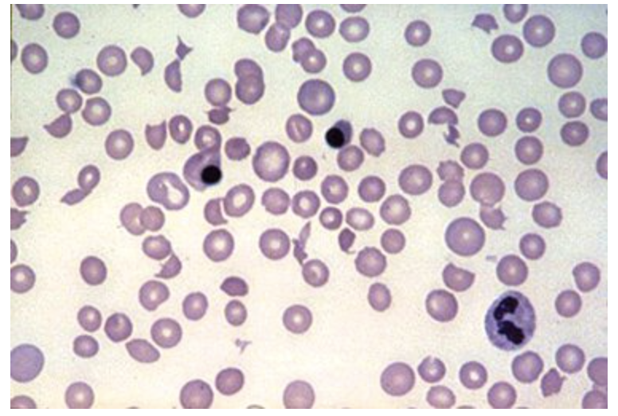

**Which of the following is the most appropriate treatment?**

1. Caplacizumab
2. Intravenous nitroprusside
3. Plasma exchange plus prednisone and rituximab
4. Platelet transfusion
5. Plasmapheresis with normal saline and 5% albumin replacement
6. A 66-year-old woman is evaluated in the emergency department for crushing chest pain. She is diagnosed with a high-risk non-ST-elevation myocardial infarction and treated with emergent percutaneous coronary intervention with a drug-eluting stent. Medical history includes a stroke 5 months ago. The patient has never had an episode of atrial fibrillation and does not have a prosthetic heart valve.

**Which of the following is the most appropriate antithrombotic treatment for this patient?**

1. Aspirin
2. Aspirin and Ticagrelor
3. Aspirin and Prasugrel
4. Aspirin, Warfarin, and Clopidogrel
5. A 77-year-old man is evaluated in the emergency department for two episodes of melena. He reports no dyspnea or lightheadedness and no hematemesis. Medical history is significant for cirrhosis secondary to hepatitis C virus, which has previously been well compensated. He also has grade 1 esophageal varices but no history of gastrointestinal bleeding. His only medication is propranolol.

On physical examination, the patient is alert and oriented. Temperature is normal, blood pressure is 85/45 mm Hg, pulse rate is 76/min, and respiration rate is 18/min. Oxygen saturation is 97% with the patient breathing ambient air. Icterus is present. Extremities are cool to touch. The abdomen is unremarkable.

Hemoglobin is 6.5 g/dL.

Two peripheral intravenous lines are inserted, and fluid resuscitation with 0.9% saline is initiated.

**Which of the following is the most appropriate additional treatment?**

1. Esophageal balloon tamponade
2. Norepinephrine
3. Packed red blood cell transfusion
4. Transjugular intrahepatic portosystemic shunt
5. A 49-year-old man is hospitalized for one day of melanotic stools. He is taking ibuprofen daily to prevent migraine headaches.

On physical examination, vital signs and physical examination findings are normal.

Laboratory studies reveal a hemoglobin level of 11.2 g/dL.

Upper endoscopy shows a 1.5 cm, clean-based, superficial duodenal ulcer. Findings from gastric biopsy specimen of Helicobacter pylori infection are pending.

Ibuprofen is stopped.

**Which of the following is the most appropriate management?**

1. Intravenous proton pump inhibitor (PPI) and hospital observation for 72 hours
2. Once-daily oral PPI, feeding, and hospital discharge
3. Once-daily oral PPI, no feeding, and hospital observation for 72 hours
4. Upper endoscopy repeated in 24 hours