- Submit a request (https://svcnowprod.service-now.com/sp/) using Request Center from a Banner computer to have your email account enabled.
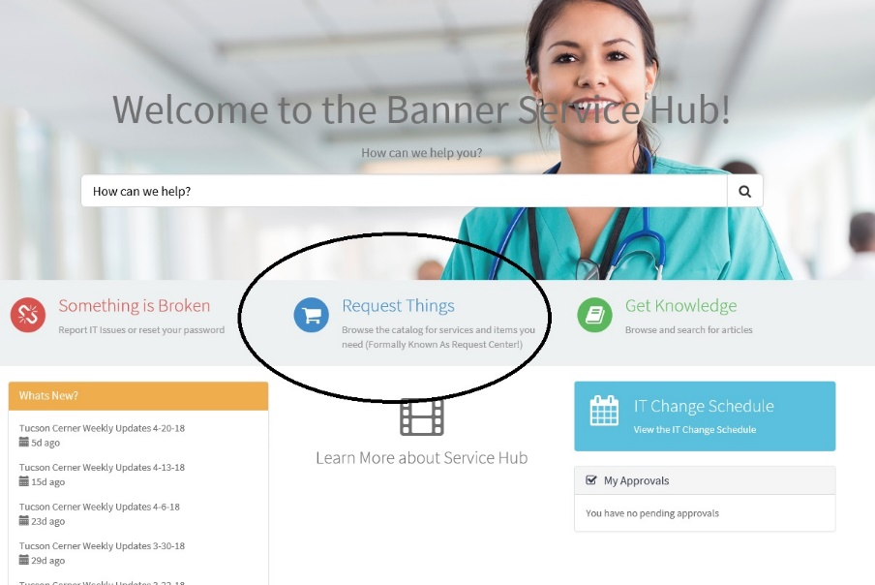
  - Click on Request things

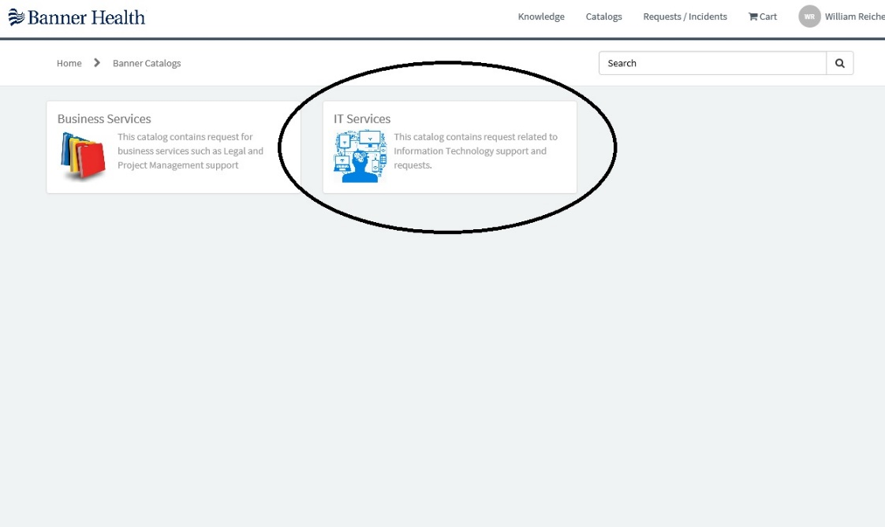
  - Click on IT Services.

  - Click on Communications & Collaboration
    - Then Email
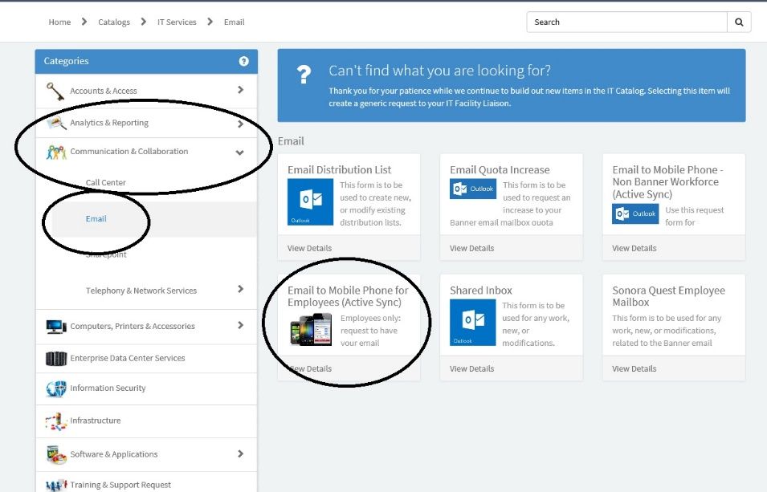
    - Then Email to mobile phone for employees (Active Sync)

  - Fill out the form and submit
  - You will receive (on the Banner email) a message stating you can start to configure your phone after 24 hours

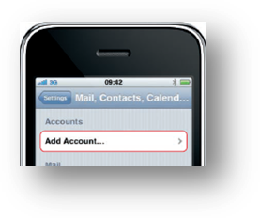
- Once you are ready to begin, click on Settings from the home page.
- Click Mail, Contacts, Calendars
- Click Add Account
- Select Microsoft Exchange
- Enter Account Information
  - Email: UserFirst.LastName@bannerhealth.com
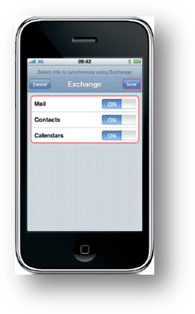
  - Server: BHMail.bannerhealth.com
  - Domain: BHS
  - Username: <LAN ID>
  - Password: <computer login password>
- Click Next.
- Select which options you want to wireless sychronize
  - Mail
  - Contacts (be careful with this, do not want every banner employee in your contacts)
  - Calendars
- Create a Passcode
*This is enforced by Banner Health as security measure
- Once the account is set up, you will get another email stating that your account is placed in quarantine. Make sure to read all the directions but basically it asks you to forward that email (from your banner email and not on your phone) to MobileDeviceActivation@bannerhealth.com to confirm it was you that set up the account. Your account should be activated in one working day.

